## TypeScript Setup

**Transpilation**

Since browsers don’t know about TypeScript we need to convert our TypeScript code into something they do understand.

The current version of JavaScript with the broadest support across all browsers is still ES5, so that’s what we currently convert our TypeScript code into.

The process of converting TypeScript into ES5 is called *transpilation* and we use a tool called tsc to compile on the command line.

* It’s useful to have the tsc tool so you can try out TypeScript yourself and transpile on the command line but it’s *not* necessary to do this in your everyday Angular development.
* Projects built using the Angular command line tools use the webpack bundler which handles transpilation of your TypeScript for you. When coding Angular via plunker SystemJS transpiles TypeScript for you in the browser.
* It is good however to have tsc installed especially if you want quickly try our some TypeScript features and see how they are transpiled into ES5 or ES6.

**Installing TypeScript**

We can install typescript via npm

npm install -g typescript

The preceding command will install the TypeScript compiler and add its executable tsc to your path.

To make sure everything worked correctly type:

tsc

–

v

And it should print something like

Version 1.8.0

**Running TypeScript**

Create a file called hello.ts.

Inside that file add console.log('hello world');

We can compile a typescript file into a javascript file by calling:

tsc hello.ts

This generates a file called hello.js

And we can execute that file by using node, like so:

node hello.js

We can watch a typescript file for changes and compile it automatically with:

tsc -w hello.ts

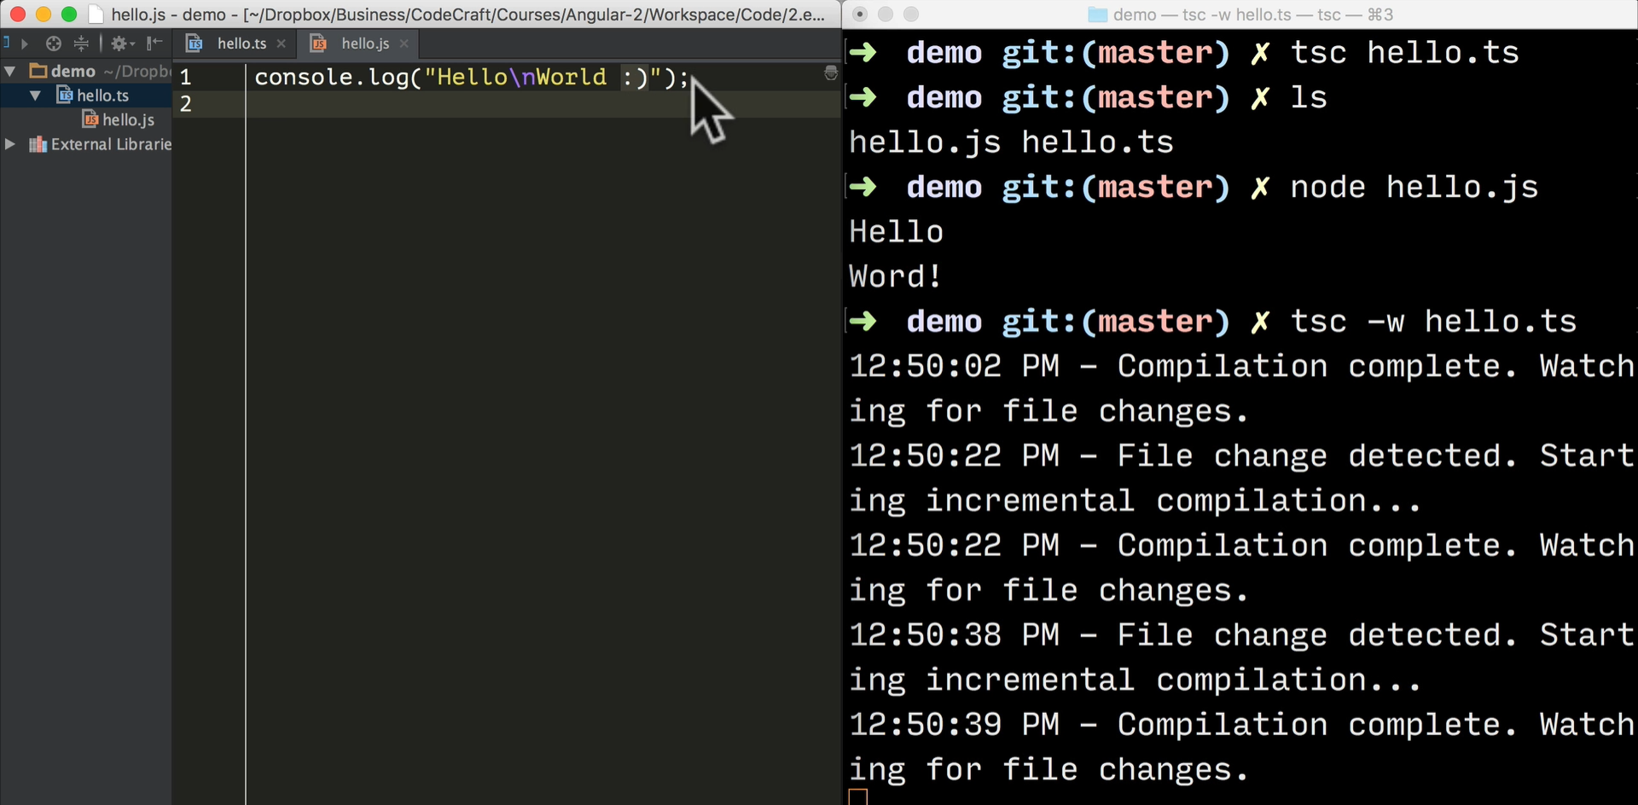

We can provide configuration on the command line, like so:

tsc -t ES6 -w hello.ts



The above

-

t ES

6

is a flag to tell typescript to transpile into ES6 instead of the

default ES5.

However if we are want to watch a whole directory we need to use a configuration file. i.e. synchronously watching all the files in a directory and transpiling whenever changes occurs in any of the file.

We can create a config file with the most common settings like so:

tsc --init

If we want to watch all files in a directory we can just type:

tsc -w

❑

If there are errors, by default TypeScript will still output the javascript file if it can,

this behaviour can be changed in the config.

